**The NEW Centurions (Membership)**

**Board of Directors Regular Meeting**

**Wednesday, November 13, 2019**

**The Sands Club - Arizona Stadium**

**545 N. National Championship Drive, Tucson, AZ 85721**

**5:00 PM**

**MINUTES**

1. **Call to Order**

A quorum of voting members was established.

Don Coleman, President, called the meeting to order at 5:00 P.M.

|  |  |
| --- | --- |
| **Board Members Present**  Voting Members:  Don Coleman, *President*  TBD, *Vice President*  Greg Amado, *Treasurer*  Kevin Bedient, *Social Chairman*  Jack Harris, *At-Large*  Ex-Officio Non-Voting Members:  Steve Shepherd, *Immediate Past President*  Dave Couture, *Membership Chairman*  Jim Tofel, *Rookie Chairman*  Chris Hanson, *Executive Director*  **Board Members Absent**  Jeff Ronstadt, *Secretary*  Bryan Hannley, *At-Large* | **Guests**  Mike Grimes  Jay Hanson  Eric Jacobson  Tom Miller  Michael Osborne  Steve Vorholzer |

1. **Consent Agenda**
2. Approve October 16, 2019 Minutes & October Financial Statements

**MOTION** to approve the consent agenda items; seconded and APPROVED.

1. **Presidents’ Reports**
2. Event. T. Miller discussed several Event planning items, including:

* Graphic design work is largely completed and will be going to print soon;
* Races are being considered to bring back for the 2020 Event;
* Four 10x10 foot on-field ‘MVP’ tents will be provided, placed left of the stage next to the VIP area, and two have already been sold;
* The Skybox Suite food will be similar for the VIP area; and
* The Special Events area will include arcade-type activities.

1. Membership. D. Coleman discussed several Membership items, including:

* With the reinstatement of Jeff Herndon, there will be 101 Active Members in 2020;
* All Directors and Members are being asked to work to ensure that all Rookies feel welcome;
* The Board needs to fill the Vice President position—D. Coleman will solicit suggestions;
* The new office space TI is coming along well, and we are getting close to completion. E. Jacobson also noted that he may have a contact for surplus office furniture.

1. **Old Business**
2. Management of Reserve Funds. G. Amado reported that he and C. Hanson are reviewing the cash flow needs and will be making a recommendation at the January meeting for how best to manage and invest the reserve funds while setting aside adequate reserve or ‘seed’ funds for future Events; there is currently $325K in a money market account and $200K in a checking account.
3. Vice President Position. The Board discussed filling the open Vice president position.

**MOTION** to appoint J. Ronstadt as Vice President subject to him resigning as Secretary and appoint D. Nentl as Secretary; seconded and MOTION FAILED.

1. **Social Report**

K. Bedient reported that we are currently under budget for the Holiday Party, and that a site has been tentatively selected for 2020 and the venue is holding December 5 for us.

1. **Charity Selection Committee**

C. Hanson reported, for B. Hannley, that The Centurions’ 2020 supported charities have been finalized: Literacy Connects, Parent Aid, and Youth On Their Own. Additional discussion by the Board included a suggestion that the charity finalists be selected by a Membership vote from among the semi-finalists.

1. **Membership Report**

D. Couture reported that he will be getting the word out at each Membership Meeting for the need to consider high quality candidates throughout the year.

**MOTION** to approve reinstating Patrick Coco as an Active Member as of January 1, 2020 and allowing 102 Active Members for 2020. **APPROVED 12/2/2019 by email ballot.**

1. **Centurion Foundation Report**

M. Osborne provided a Foundation Board update, including:

* The Foundation will be meeting quarterly through the coming year;
* A Marketing Committee has been created to promote the Foundation and its development efforts;
* Plans are forming to ask The New Centurions’ Members for donations;
* A gift acceptance policy has been developed; and
* TMC Foundation has granted the Foundation a $25K in matching funds for TMC’s opioid program.

1. **Executive Director’s Report**

C. Hanson reported on several items, including:

* Articles of Incorporation for all three entities have been approved by the State and the name change from ‘The Centurion of Southern Arizona Charitable Foundation’ to ‘The Centurions’ is complete;
* Delivered checks for our 2019 charity funding for the three charities;
* Conducted public check presentations with all three 2019 charities organizations and a check presentation event is being planned with TMC Foundation for January 2020;
* Attended the National Philanthropy Day Luncheon on November 15—The Centurions were the recipient of the Spirit of Philanthropy Award, having been nominated by TMC Foundation;
* Will be attending the TMC Annual Gala with a group of Centurions Members on November 16;
* We purchased 200 tickets for the Gaslight Theatre holiday matinee show on December 8, which will be invoiced to Members attending at $20 for adults and $12 for children ages 2-12.
* TI work at the new office space is advancing well is expected to be completed by mid-December.

1. **New Business**

No new business was discussed.

1. **Adjournment**

With there being no further business, the meeting was adjourned at 5:58 PM.

**Attachment 1**

**MOTION** to approve reinstating Patrick Coco as an Active Member as of January 1, 2020 and allowing 102 Active Members for 2020. **APPROVED 12/2/2019 by email ballot.**

**A. EMAIL BALLOT**

**From:** Chris Hanson   
**Sent:** Monday, December 2, 2019 2:59 PM  
**To:** Membership Board <membershipBOD@thecenturions.com>  
**Subject:** Centurions Memb. Board - Vote on Reinstating Pat Coco as an Active Member

Membership Board Members,

I hope you had a great Thanksgiving!

Patrick Coco is requesting to be reinstated as an Active Member, after having stepped aside for two years (see attached). Approving Pat would put us 102 Active Members for 2020 (the Board approved reinstating Jeff Herndon, which put us at 101).

Since the Rules specify no more than 100 Active Members, we’ll just need to also approve overriding the Rules to allow Pat back in, which we can do in the same motion.

**\* Please provide me with your vote to reinstating Pat**—we’ll need all Board Members to cast a ballot and a majority affirmative vote to approve this by email:

**MOTION to approve reinstating Patrick Coco as an Active Member as of January 1, 2020, and allowing 102 Active Members for 2020.**

Should not everyone cast a ballot, or should anyone request to discuss this before voting, we’ll add this as an agenda item for our January 2020 Board meeting.

Thanks,

Chris

**Chris Hanson**

Executive Director | [**The Centurions**](https://www.thecenturions.com/)

5301 E. Grant Road, Tucson, AZ 85712

520.795.1071 O | 520.906.3001

**B. PATRICK COCO’S REQUEST TO BE REINSTATED AS AN ACTIVE MEMBER**

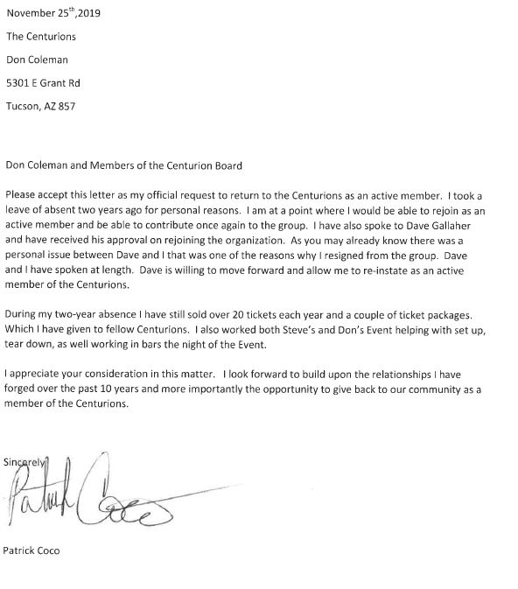

**C. VOTES**

**From:** Bryan Hannley <bryan.hannley@gmail.com>

**Sent:** Monday, December 2, 2019 3:49 PM

**To:** Chris Hanson

**Subject:** Re: Centurions Memb. Board - Vote on Reinstating Pat Coco as an Active Member

I vote yes

**From:** Jack Harris <jack@jackharris.org>   
**Sent:** Monday, December 2, 2019 3:43 PM  
**To:** Chris Hanson <chris.hanson@thecenturions.com>  
**Cc:** Membership Board <membershipBOD@thecenturions.com>  
**Subject:** Re: Centurions Memb. Board - Vote on Reinstating Pat Coco as an Active Member

I vote yes to the motion to reinstate Pat.

**From:** Jeff Ronstadt <jeffr@ronstadtinsurance.com>   
**Sent:** Monday, December 2, 2019 3:34 PM  
**To:** Chris Hanson <chris.hanson@thecenturions.com>  
**Subject:** Re: Centurions Memb. Board - Vote on Reinstating Pat Coco as an Active Member

Yes to both motions.

**From:** Kevin Bedient <kevin@advantageairmechanical.com>   
**Sent:** Monday, December 2, 2019 3:20 PM  
**To:** Chris Hanson <chris.hanson@thecenturions.com>  
**Subject:** Re: Centurions Memb. Board - Vote on Reinstating Pat Coco as an Active Member

I vote yes

**From:** Don Coleman <don@mayfieldflorist.com>   
**Sent:** Monday, December 2, 2019 3:16 PM  
**To:** Chris Hanson <chris.hanson@thecenturions.com>  
**Subject:** Re: Centurions Memb. Board - Vote on Reinstating Pat Coco as an Active Member

Approved

**From:** Chris Hanson   
**Sent:** Monday, December 2, 2019 3:17 PM  
**To:** Membership Board <membershipBOD@thecenturions.com>  
**Subject:** RE: Centurions Memb. Board - Vote on Reinstating Pat Coco as an Active Member

All, I just spoke with Dave Gallaher and he is completely good with Pat being reinstated.

**From:** Greg Amado <GAmado@amadoandassociates.com>   
**Sent:** Monday, December 2, 2019 3:05 PM  
**To:** Chris Hanson <chris.hanson@thecenturions.com>; Membership Board <membershipBOD@thecenturions.com>  
**Subject:** RE: Centurions Memb. Board - Vote on Reinstating Pat Coco as an Active Member

I vote to approve the motion as stated below.

I think Chris should obtain confirmation from Dave that he is good with the reinstatement. I do not need to know the issue…it is none of my business…but just a confirmation that Dave is good with the reinstatement.